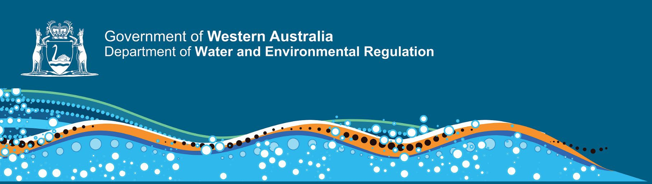

 | Environmental Officer – Specified Calling Level 1 | Environmental Officer – Specified Calling Level 2 | Senior Environmental Officer – Specified Calling Level 3
 | Role requirements:
Qualification requirement/or occupational specific experience | All Specified Calling positions require a Bachelor of Science degree, or an approved equivalent tertiary qualification
Role Specific Requirements | - Ability to undertake assigned tasks to contribute to environmental compliance operations and inspections.  - Ability to understand and apply legislation and policy to support operational and organisational objectives.  - Awareness of contemporary environmental issues with an understanding of the principles and practices of environmental management.  - Analytical, observational, and problem-solving capability with the ability to undertake preliminary research and data analysis to support the development of practical evidence-based solutions. | - Demonstrated experience in undertaking compliance inspections and audits to achieve appropriate outcomes.  - Proven ability to understand and apply legislation and policy to support operational and organisational objectives.  - Understanding of contemporary environmental issues with an understanding of the principles and practices of environmental management.  - Ability to conceptualise, analyse and evaluate complex information and make accurate evidence-based conclusions to inform decision makers. | - Demonstrated experience in undertaking compliance inspections and audits to achieve appropriate outcomes.  o identify, interpret, and deliver appropriate legislative, regulatory and policy solutions.  o acquire and interpret technical and scientific advice; and  o develop recommendations and/or make decisions.  - Well-developed working knowledge and understanding of contemporary environmental management issues facing Western Australia and of government policies and strategies to address these issues.  - Well-developed research skills with the ability to critically analyse complex technical issues, identify and manage risks and form sustainable solutions.
Achieving Results | - Demonstrated ability to work to agreed objectives within a team. Able to contribute to and support business improvements and be responsive to change. | - Demonstrated experience in managing and delivering assigned work outcomes while contributing to team priorities. Able to respond to changing priorities and identify opportunities for continuous improvement. | - Demonstrated experience in leading, planning, prioritising, and managing competing projects and identifying opportunities for continuous improvement. Proven ability to achieve results that support key operational objectives.
Interpersonal | - Ability to work cooperatively within a team and sustain positive relationships with stakeholders. Supports and contributes to the development of new ideas and ways of working. | Demonstrates ability to work effectively within a team. Forms and maintains positive relationships with diverse stakeholders to deliver business outcomes. Contributes and supports new ideas and ways of working. | - Demonstrate ability to manage projects and/or a team, supervising and mentoring team members while encouraging and implementing new ideas.  - Well-developed interpersonal skills with the ability to build relationships, collaborate and negotiate effective outcomes with a diverse range of  stakeholders.
Communication | - Ability to communicate effectively through various mediums (oral and written). Able to produce correspondence and reports that meet the needs of target audiences. | - Well-developed oral and written communication skills including the demonstrated ability to write reports, present technical information and interpret information succinctly for target audiences. | - Well-developed written and oral communication skills, with the proven ability to distil complex issues into succinct messages for targeted audiences and produce high quality correspondence, reports, documents.
Special Requirements | - Ability to travel to local and remote field locations to undertake environmental compliance inspections.  - Ability to undertake inspections in remote areas in sometimes harsh climate conditions with limited supervision.  - Current “C” class motor vehicle driver’s licence. | - Ability to travel to local and remote field locations to undertake environmental compliance inspections.  - Ability to undertake inspections in remote areas in sometimes harsh climate conditions with limited supervision.  - Current “C” class motor vehicle driver’s licence. | - Ability to travel to local and remote field locations to undertake environmental compliance inspections.  - Ability to undertake inspections in remote areas in sometimes harsh climate conditions with limited supervision.  - Current “C” class motor vehicle driver’s licence.

Our values-based culture reflects who we are and how we go about business.
While your qualifications and experience tell us part of your story, your values and attitude speak louder still. At DWER our culture lives the organisational values created by our people. During the selection process you will be assessed on your ability to fulfil the responsibilities of this position while upholding our values.
We care | We build trust | Better together | Open minds | We serve to make a difference.
